**FaceTrace AI: Intelligent Face Detection and Matching System**

**WORKING FLOWCHART OF THE PROJECT:**

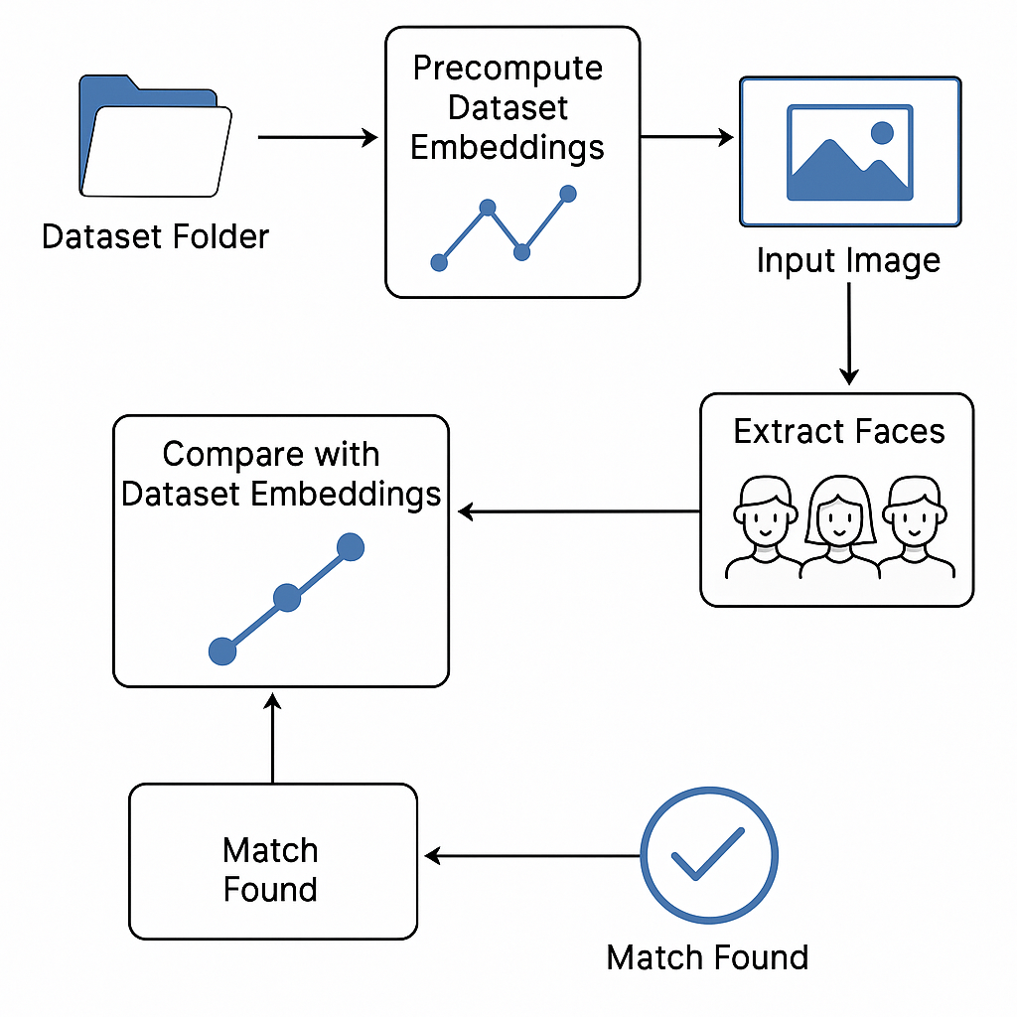

**POSTGRESQL DATABASE(ONLINE GOOGLE CLOUD FOR STORING ALL IMAGE EMBEDDINGS ON FACES)  
  
a free website I used is Avien Google Cloud**

* **Why do I use Postgresql other than all databases?**PostgreSQL runs on various operating systems, including Windows, macOS, and Linux, making it versatile for different environments. PostgreSQL is designed to handle large volumes of data and can scale well with increasing workloads. It supports various indexing techniques, partitioning, and parallel query execution to enhance performance. PostgreSQL is designed to handle large volumes of data and can scale well with increasing workloads. It supports various indexing techniques, partitioning, and parallel query execution to enhance performance.

**Why do I embeddings on the image's faces than the trained model?**

Using embeddings for facial images can be advantageous due to their efficiency, ease of use, and ability to leverage pre-trained models. They are particularly useful for applications that require quick comparisons or clustering of images. On the other hand, CNNs are powerful tools for tasks that require detailed analysis and classification of images. The choice between using embeddings and CNNs depends on the specific requirements of the application, the available data, and the computational resources.

**Key Concepts**:

* OpenCV (cv2) is used for face detection and image preprocessing
* CLIP model handles image embeddings for similarity comparison
* Environment variable suppresses warning messages about symlinks

A **symlink** (short for *symbolic link*, also known as a *soft link*) is a special type of file in a file system that acts as a reference or pointer to another file or directory, called the *target*. You can think of a symlink as a shortcut: when you access the symlink, the operating system transparently redirects you to the target file or directory, allowing you to interact with it as if you were accessing the original location

**Technical Details**:

* Uses CLIP's base variant with 16x16 patch size
* Model outputs 512-dimensional image embeddings
* Exception handling prevents silent failures

**Uses CLIP's base variant with 16x16 patch size**

This refers to a model architecture based on OpenAI’s CLIP (Contrastive Language-Image Pre-training), specifically the "base" variant that uses a Vision Transformer (ViT) image encoder. In this configuration, each input image is divided into patches of 16x16 pixels, which are then processed by the model. This patch-based approach is characteristic of Vision Transformers and allows the model to efficiently capture spatial information from images[1](https://www.promptlayer.com/models/xclip-base-patch16)[2](https://www.pinecone.io/learn/clip-image-search/)[3](https://www.pingcap.com/article/a-comprehensive-guide-to-openais-clip-model/).

**Model outputs 512-dimensional image embeddings**

The model processes an image and produces a 512-dimensional vector (embedding) that represents the image’s content in a high-level, abstract way. These embeddings are designed so that similar images (or images and their corresponding text descriptions) are close to each other in this high-dimensional space. The 512-dimensional output is standard for CLIP’s base models and is used for tasks like image search, classification, and retrieval[2](https://www.pinecone.io/learn/clip-image-search/)[3](https://www.pingcap.com/article/a-comprehensive-guide-to-openais-clip-model/).

**Exception handling prevents silent failures**

This means the model or the code that uses it is designed with robust error handling. Instead of ignoring errors (which leads to "silent failures" that are hard to detect and debug), the system explicitly catches and manages exceptions. This is considered a best practice in AI/ML systems, as silent failures can cause data corruption, inaccurate results, or system crashes. Proper exception handling ensures that errors are logged, reported, ormanaged gracefully, improving the reliability and maintainability of the system[4](https://pybit.es/articles/python-errors-should-not-pass-silently/)[5](https://www.33rdsquare.com/exception-handling-in-python/).

**### 1. Library Imports & Environment Setup**

- OpenCV (cv2) is used for face detection and image preprocessing

- CLIP model handles image embeddings for similarity comparison

- Environment variable suppresses warning messages about symlinks

**### 2. Model Initialization**

- Uses CLIP's base variant with 16x16 patch size

- Model outputs 512-dimensional image embeddings

- Exception handling prevents silent failures

**### 3. Image Preprocessing**

- 2x upscaling improves face detection accuracy

- Gaussian blur reduces high-frequency noise

- Histogram equalization enhances contrast

**### 4. Face Detection with Haar Cascades**

- scaleFactor=1.2: 20% reduction at each scale

- minNeighbors=5: Requires 5 neighbor rectangles for face confirmation

- minSize=(50,50) filters small false positives

**### 5. CLIP Embedding Generation**

- CLIP requires 224x224 RGB input

- get_image_features() extracts final layer embeddings

- L2 normalization enables cosine similarity comparison

**### 6. Similarity Matching**

- Uses cosine similarity

- Threshold 0.85 corresponds to ~31° angle between vectors

- Dynamic threshold could improve accuracy

### Technical Questions

Q1: Why use CLIP instead of traditional face recognition models?

A: CLIP enables zero-shot recognition without retraining, handles novel classes through natural language understanding, and provides robust embeddings for various visual concepts.

Q2: How would you improve the face detection accuracy?

A: Implement multi-stage detection using MTCNN, face alignment, and non-maximum suppression.

Q3: What are the limitations of cosine similarity here?

A: Assumes linear separability, sensitive to embedding normalization, and doesn't account for hierarchical feature relationships.

### System Design Questions

Q4: How would you scale this for 1 million face database?

A: Use Approximate Nearest Neighbors (ANN) with FAISS/HNSW, embedding quantization, and batch processing with GPU.

Q5: How to handle real-time video input?

A: Use frame sampling, threaded producer-consumer pattern, and edge detection-based region proposal.

### Conceptual Questions

Q6: Explain CLIP's contrastive learning process

A: CLIP trains on 400M image-text pairs using symmetric contrastive loss.

Q7: Why normalize embeddings before comparison?

A: Normalization makes vector magnitude invariant, reduces false matches, and enables cosine similarity.

## Optimization Opportunities

- Replace Haar Cascades with YOLO-face

- Implement async I/O for image loading

- Add face alignment before embedding generation

- Use quantization-aware training for CLIP

- Add temperature scaling to similarity calculation

This implementation demonstrates a practical application of traditional computer vision combined with modern vision-language models.

'''

<https://www.perplexity.ai/search/import-cv2-import-os-import-nu-wUvmoNgTRvyIzJfCu9qujQ>

1. **Can you explain the main steps of your face detection and recognition pipeline?**

**Answer:**  
Certainly! The pipeline consists of four main steps:

1. **Image Preprocessing:** The input image is resized, blurred to reduce noise, and converted to grayscale. Histogram equalization is applied to improve contrast for better face detection.
2. **Face Detection:** Using a Haar Cascade classifier, faces are detected in the preprocessed image.
3. **Face Extraction:** Detected faces are cropped and saved as individual images.
4. **Face Recognition:** Each extracted face is converted to an embedding using the CLIP model. These embeddings are compared with precomputed embeddings from a dataset using cosine similarity to find the closest match.

2. **Why did you choose the Haar Cascade classifier for face detection? What are its pros and cons?**

**Answer:**  
I chose Haar Cascade because it is fast, works well for frontal faces, and is easy to implement with OpenCV.  
**Pros:**

* **Fast detection** on standard hardware.
* **Lightweight** compared to deep learning models.
* **Works well for frontal faces** in controlled environments.  
  **Cons:**
* **Less robust** to variations in pose, lighting, or occlusions.
* **Higher false positives/negatives** compared to modern deep learning-based detectors.

3. **How does the CLIP model help in this project, and why did you use it for face recognition?**

**Answer:**  
CLIP (Contrastive Language–Image Pretraining) is a vision-language model trained to understand images and text together. In this project, I use CLIP to generate image embeddings for faces.  
**Why CLIP?**

* **State-of-the-art embeddings:** CLIP produces robust, generalizable image embeddings.
* **No need for fine-tuning:** It works well out of the box for many tasks, including face recognition if the dataset is diverse.
* **Flexibility:** Can be adapted for zero-shot or few-shot learning scenarios.

4. **How do you measure the similarity between two face embeddings, and why did you choose this method?**

**Answer:**  
I use **cosine similarity** to measure how similar two embeddings are. Cosine similarity calculates the cosine of the angle between two vectors in embedding space, giving a value between -1 and 1, where 1 means identical.  
**Why this method?**

* **Normalization:** Embeddings are normalized, so cosine similarity directly measures their directionality, ignoring magnitude.
* **Robustness:** It is widely used in face recognition systems for comparing high-dimensional vectors.

5. **How do you handle cases where no face is detected in the input image?**

**Answer:**  
If no face is detected by the Haar Cascade classifier, the function returns an empty list. The script then skips the recognition step for that case and continues execution, providing appropriate feedback to the user.

6. **What challenges did you face while implementing this project, and how did you overcome them?**

**Answer:**  
One challenge was **balancing detection accuracy with processing speed**. Haar Cascade sometimes misses faces or detects false positives. To address this, I experimented with preprocessing steps (like resizing and histogram equalization) and adjusted detection parameters.  
Another challenge was **managing large embeddings** and ensuring efficient comparison. I precomputed embeddings for the dataset to speed up recognition.

7. **How would you improve the accuracy of your face recognition system?**

**Answer:**

* **Use a deep learning-based face detector** (like MTCNN or RetinaFace) for better detection accuracy.
* **Fine-tune the CLIP model** on a face-specific dataset if possible.
* **Augment the dataset** with more diverse images to improve generalization.
* **Experiment with different similarity thresholds** to reduce false matches.

8. **Can you explain the role of image preprocessing in your pipeline?**

**Answer:**  
Image preprocessing is crucial for improving the performance of the Haar Cascade classifier. By resizing the image, applying Gaussian blur, and using histogram equalization, I reduce noise, enhance contrast, and standardize the input, which helps the classifier detect faces more reliably.

9. **How do you ensure your code is robust and handles errors gracefully?**

**Answer:**  
I use exception handling to catch and report errors during model loading, image processing, and embedding calculation. I also check if files and directories exist before processing and provide clear feedback to the user if something goes wrong.

10. **What is the purpose of normalizing the embeddings before comparison?**

**Answer:**  
Normalizing embeddings (making their length 1) ensures that cosine similarity depends only on the angle between the vectors, not their magnitudes. This makes the similarity measure more consistent and reliable for comparing images.